MEETING SUMMARY
MRIP EXECUTIVE STEERING COMMITTEE CONFERENCE CALL
February 9, 2015; 3:00 – 4:30 pm EST

In attendance: Executive Steering Committee (ESC) members and participants: John Boreman, Chair, Gordon Colvin, Bob Beal, Bonnie Ponwith, Doug Mecum, Ned Cyr, Russ Dunn, Emily Menashes, David Donaldson, Steve Williams (for Randy Fisher), Kitty Simonds, Miguel Rolon. Other attendees: Pres Pate, Rob Andrews, Lauren Dolinger Few, Leah Sharpe, Dave Van Voorhees, David Detlor, and Chris Wright.

- Budget priorities and updated FY 15 spend plan:

Dave Van Voorhees first reviewed the current version of the FY 15 MRIP Spend Plan. We expect to have $10.237M available for MRIP work this year. Assuming all lines are essentially level funded from last year, and adding costs for the FES benchmark survey ($1.218M) and funds needed to maintain Florida sampling levels ($100K), and fully funding IMT and OT projects, results in a deficit of $1.899M. Dave outlined a series of funding reductions in the plan, including: a reduction in contract-supported work resulting from having a positive balance at the end of FY 14 that can be carried into FY 15, offsetting some of the FY 15 required amounts (Dave also indicated that the level actually expended in FY 14 is probably sufficient for annual expenditures in these lines going forward); and reduction in IT support resulting from transfer of MDMS costs to other lines in ST. As a result, the deficit in the Spend Plan was reduced to $395K. The staff will continue to work to seek cost reconciliation, and will advise the ESC of developments. However, due to the significant reduction in the magnitude of the projected deficit since the last meeting, it was not necessary to seek ESC advice on priorities for reduction. David Donaldson and Steve Williams acknowledged and expressed support for continuing the supplements included in FY 14 and 15 for sampling in the Gulf and Pacific states.

Dave Van Voorhees also reviewed a spreadsheet that outlined overall ST 1 expenditures for recreational catch data collection, organized by Region. The ESC had requested this overall national picture of survey costs at its last meeting. The ESC members and participants indicated that this table was helpful and informative, and satisfied their need for seeing the overall picture.
2. Operations Team’s Proposed Implementation Funding Process

At the ESC’s July 2013 Regional Implementation Workshop, the Operations Team was tasked with developing new Terms of Reference that outlined a role for the OT in determining priorities for MRIP implementation funding in a regional implementation context. At its 24 January 2014 meeting, the ESC approved the new OT Terms of Reference, including: “The OT will establish a cross-regional process for prioritizing options for NMFS/MRIP investment in implementation of improved recreational fishing data collection methods based on the foregoing characteristics of surveys and resultant recreational statistics.”

Rob Andrews outlined the provisions of the proposed Implementation Funding Process document, appended below (Attachment 1), which was developed by the OT in response to this charge. The OT approved the document at its November 2014 meeting. David Donaldson and Steve Williams asked when the process outlined in the document would be initiated, and indicated a preference to do so for next year (to follow expected submission of survey designs for MRIP certification in the Gulf and Pacific regions this year). Rob and Dave Vann Voorhees stated that the process could be implemented for FY 16. Steve Williams asked if the process for developing regional implementation plans could be incorporated into existing operational and grant procedures the FINs now follow. Rob responded that it would be most efficient to do so, and is the preferred approach (Note: this subject is addressed in the last paragraph of the document). There were no objections to approving the document and initiating its use in annual decision-making for implementation funding. Accordingly, the MRIP document titled Implementation Funding Process is approved, and will be posted to the MRIP website. MRIP staff and the OT will provide advice to begin its use in setting implementation priorities for FY 16.

- Potential NRC review and role of ESC in developing its terms of reference

Gordon Colvin reported on the recent discussions of the MRIP Team Leads regarding the question of initiating a new NRC review of MRIP. He noted that it has been our position, most recently affirmed by Richard Merrick in a Congressional hearing in 2014, that NMFS will seek a new NRC review of MRIP once a sufficient body of work has been completed to warrant the expenditure of time and funding resources. Richard has spoken to Susan Roberts at NRC, and has confirmed that the NRC would be willing to carry out a review. Over the last year there have been an increasing number of external calls for such a review, including a proposed amendment to the MSA. To that end, the Team Leads now believe that, with the completion of the work to certify the FES, MRIP has made sufficient progress, and that it now makes sense to take the initiative to establish the scope and timing of such a review ourselves. Otherwise, we may be subject to a review with an unreasonable and unaffordable schedule and scope. Accordingly, the Team Leads recommend that we make a public commitment to initiating a NRC review for FY 16, and begin the process of scoping the review and working out Terms of Reference and a contract with the NRC this year.

The ESC discussed the recommendation, and all agreed that it is appropriate to proceed as recommended by the Team Leads. Several issues were identified that should be considered as we proceed:
- John Boreman noted that it is important to properly scope the review. We want a program-level review, and should not conduct a review at a level that reviews the details of survey designs that MRIP has developed and certified. It is neither necessary nor appropriate to subject specific survey designs to a second peer review, once they have been approved. Rather, the process by which MRIP has developed and certified new designs, and the progress MRIP has made toward addressing the recommendations of the previous review, should be the focus of a new review.
- Ned Cyr noted the need to address questions regarding the timing of a review and its cost. It is preferable to initiate a review sooner than later. But, the cost will be at least $500K, and there is no provision for it in the FY 15 budget and spend plan. So, we would need to find a way to fund the work in the FY 16 budget.
- Bob Beal, David Donaldson, and Steve Williams all spoke in support of conducting the review. All also expressed concern that it not affect the availability of MRIP funds for support of the FIN work, especially given the initiation of state conduct of the APAIS on the Atlantic coast, and the long-term level funding of the GulfFIN and PacFIN programs.
- John Boreman noted that it may be possible to make a case for funding at the agency level. We can pursue that possibility as we make our recommendation to proceed to the NMFS Leadership.

It was agreed that the ESC will recommend to the NMFS Leadership that we announce soon a public commitment to initiate a NRC review of MRIP in FY 16. John Boreman will work with the MRIP Teams to draft Terms of Reference for a review, and will provide them to the ESC for comment in late March/early April.
4. Continued Outreach Plan for The Marine Recreational Information Program’s New Fishing Effort Survey and Transition Strategy

Leah Sharpe reviewed the draft document, Continued Outreach Plan for The Marine Recreational Information Program’s New Fishing Effort Survey and Transition Strategy. This plan is in development by the Communications and Education Team (CET), and will be a living document that will evolve as the FES benchmarking effort is conducted, and as the Transition Plan for the FES is completed and executed. There will be specific, detailed, Roll Out Plans for each of the major milestones identified in the plan, including the initiation of the FES benchmarking survey later this month. The CET is also continuing to work toward establishing regional communications teams, and will enlist them in supporting implementation of the overall plan and individual Roll Out Plans going forward. Dr. Sharpe asked the ESC to provide feedback on the plan.

Kitty Simonds noted that the Western Pacific Council is hosting a meeting in March that will address outreach strategies in the region. Following that meeting, Sylvia Spalding will get back to the CET will suggestions for how to work with a team for that region.

Dave Donaldson noted that the GSMFC is meeting in March, and that Gordon Colvin and Leah Sharpe will be attending. That meeting will be an opportunity to discuss how to establish a regional team for the Gulf region and to discuss the particulars of our outreach plans.

Gordon Colvin suggested that the ESC members provide specific feedback on what measures we need to include in the plan to build grass roots stakeholder and partner awareness and support for the methodology and the transition process.

The ESC will review the draft plan and provide their advice and comments to Leah Sharpe by the end of February.
5. FES Transition Plan

Dave Van Voorhees reported on the progress of the Transition Team. The Team has been established and has met several times. Currently, the focus is on developing a specific Transition Plan for the FES, and an Atlantic and Gulf sub-group has been established for that purpose. It is expected that the FES Transition Plan can be used as a model for other plans the full team will develop in the future. The sub-group is meeting weekly.

The sub-group has focused on two alternative strategies/schedules: one provides for benchmarking for one full year while a calibration method is developed, initiating calibration after one year while benchmarking continues, beginning to update stock assessments in the second year, and then applying the calibrated assessment results to management actions in the third year (2017). The second strategy provides for a second full year of benchmarking before calibration is attempted, pushing the implementation schedule back one year. A draft timeline illustrating the two options was provided and is attached to this summary (Attachment 2 below). The sub group is completing a detailed examination of the pros and cons of each option.

The sub-group has now divided into stock assessment and management teams. Each of them is preparing a detailed assessment of the necessary schedules and other considerations to be addressed in the Transition Plan.

Bob Beal asked whether the team has considered the implications for assessment resources and the impacts on established SEDAR/NRCC stock assessment schedules. Dr. Van Voorhees responded that the stock assessment team will include those considerations in its report.

ATTACHMENT 1

DRAFT
Implementation Funding Process

To address MRIP’s focus on implementation, the Executive Steering Committee (ESC) charged the MRIP Operations Team (OT) with the “development of recommendations for NMFS/MRIP to make additional investments in survey implementation and operations” of recreational survey methods. The goals of this process are to, 1) support implementation of certified methods that satisfy the minimum needs for management and science, and result in regional survey programs that achieve at least the minimum MRIP standards for coverage, resolution, and data elements, and 2) establish a consistent, priority-based foundation for investment of available funds for data collections that exceed minimum needs.

Implementation funds will be allotted from “new” MRIP funding, as current funding allocations (e.g. FIN funding) will likely remain level. Additionally, funding will not be used to replace existing partner funds for recreational fisheries data collection.

National Guidelines

MRIP has established National guidelines for the prioritization of NMFS’ investments in implementation of new survey methods. Specifically, funding priority will be based upon the extent to which surveys, alone or in combination with other surveys being implemented in a region:

- Utilize MRIP-certified survey designs or methodologies;
- Achieve MRIP standards for survey coverage and basic data elements, as well as any future standards adopted by the program (http://www.st.nmfs.noaa.gov/Assets/recreational/pdf/National_Standards_for_Survey_Coverage_and_Data_Elements.pdf);
- Provide recreational (or non-commercial) catch estimates for fisheries managed under MSRA—including Atlantic HMS—or jointly by the states and NMFS that are sufficient to
  - Contribute to reliable stock assessments;
  - Support development of acceptable biological catch recommendations, annual catch limits (ACLs), and accountability measures that meet MSRA requirements; and
  - Support development of recreational regulations that minimize triggering of accountability measures.
  - Allow reasonably precise tracking of recreational catch against ACLs

Regional Planning

Each Regional Implementation Team is responsible for identifying regional needs and developing a plan to implement improved data collection designs that address both regional and national needs. Regional implementation plans, which will be reviewed and approved by the OT and ESC, will provide estimated implementation costs, and will reflect consensus among partners within a region with respect to regional needs and implementation priorities.

Regional implementation plans will include:
- Descriptions of regional needs for recreational fishing statistics, including needs for coverage, resolution, precision and timeliness of survey estimates;
- A baseline assessment of current data collection programs, including the extent to which current programs satisfy needs and identification of data collection gaps;
- Recommendations and justification for a sequential, prioritized approach for implementing improved methods that address national and regional needs that are currently unmet;
- A proposed process for combining statistics derived from multiple sources;
- Estimated costs, overall and for individual survey components.

Each year, the NMFS Office of Science and Technology (OST) will review regional implementation plans and establish agency funding priorities across regional programs. OST will develop metrics, based on the above National guidelines and subject to ESC review and approval, for assessing the Regional Implementation Plans and setting OST priorities. To the extent possible, funding for improved survey methods will be permanent, and funded survey components will not be subjected to prioritization and evaluation in subsequent years. Evaluation and prioritization in subsequent years will be limited to unfunded data collections described in the implementation plans. Exceptions will be made in the event of reduced and/or insufficient funding to cover the costs of approved data collections and/or changes to regional priorities, which will be reassessed at a minimum of every five years, coincidental to NMFS’ science program review cycle. Funding may also be reallocated if it is determined by the ESC or OST that expenditures are inconsistent with the approaches described in the regional implementation plans.

Program Reporting

Regional implementation Teams are expected to submit annual reports describing progress in executing Regional Implementation Plans. Annual reports will describe MRIP data collection activities, document expenditures and assess the extent to which regional goals and needs for recreational fisheries statistics have been satisfied. For regional partnerships currently funded through a NMFS grant (e.g., ACCSP, GulfFIN, Pacific RecFIN), MRIP program updates can be incorporated into existing reporting requirements (e.g., annual grant reports).

ATTACHMENT 2

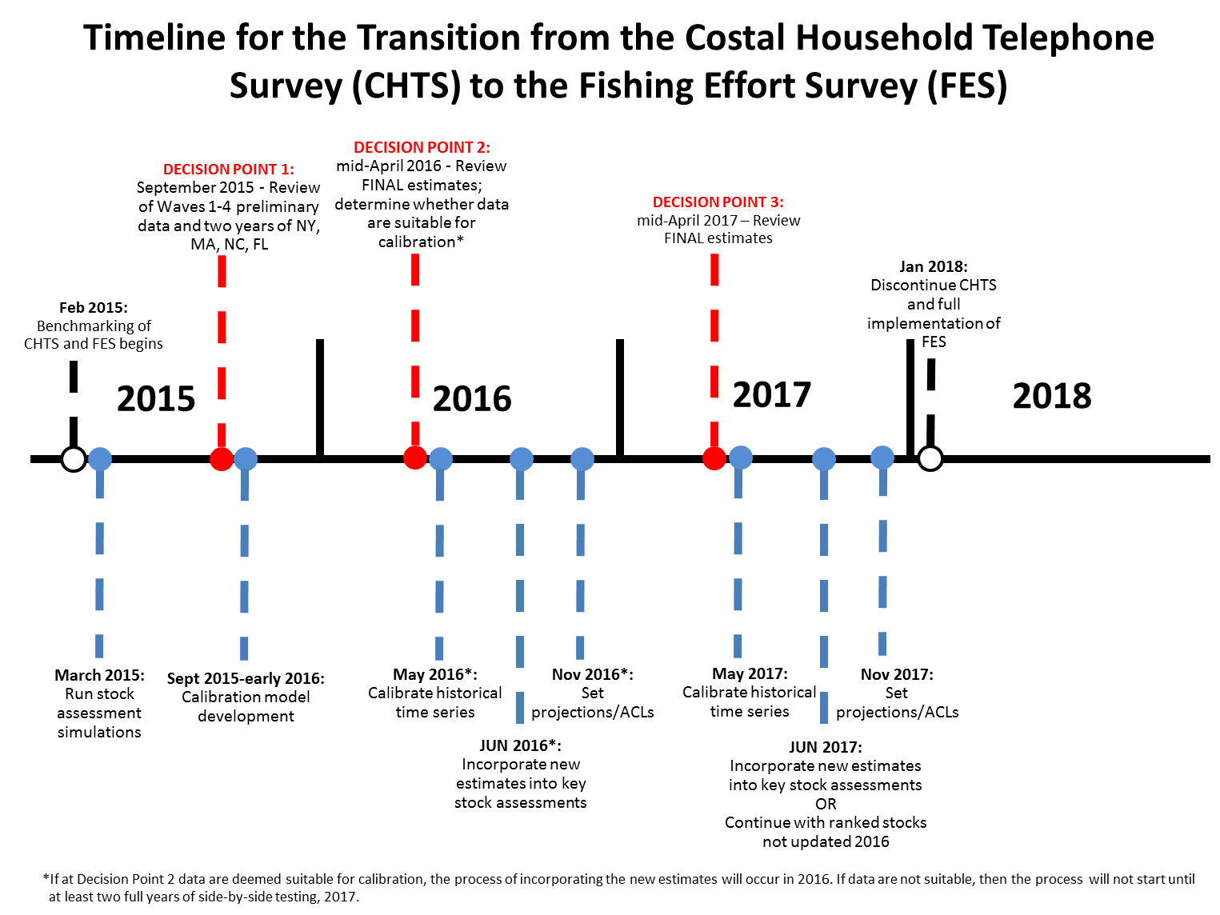

¹MRIP certification is granted after the proposed method has undergone MRIP-led internal and external peer review and has been determined to be a statistically sound and credible method for estimating catch and effort data.
The MRIP Executive Steering Committee (ESC) determined that regional Fishery Information Networks (FIN’s) and their equivalents will serve as the MRIP Regional Implementation Teams (http://www.st.nmfs.noaa.gov/Assets/recreational/pdf/2013-2014%20Implementation%20Plan%20Update.pdf)
For example, regions may implement data collections that are specific to a sector or species. Implementation plans should describe how information generated from these sources will be integrated with more generalized data collections to either supplement or replace alternative estimates.
http://www.st.nmfs.noaa.gov/science-program-review/index

