IMPORTING CSV FILES INTO EXCEL WITHOUT LOSING PRECISION

Any column that contains large numbers, or values that could be read as large numbers, must be read into EXCEL as text in order to avoid rounding and scientific notation. Follow the steps below to import the CSV into EXCEL and format those columns as text at the time of import.

STEP 1
Open Excel and on a blank worksheet select the DATA tab at the top

STEP 2
Select the FROM TEXT button under the GET EXTERNAL DATA section

STEP 3
In the Import Text File window that opens, navigate to the CSV file you wish to import and select IMPORT.
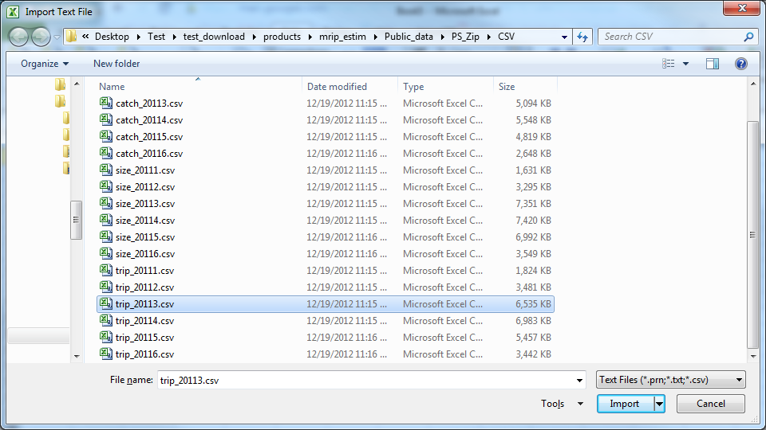

STEP 4
In The Text Import Wizard click NEXT on step 1 of 3.

STEP 5
For step 2 of 3 in the Text Import Wizard, change the delimiter to COMMA and the text qualifier to {NONE}. Click NEXT when finished.
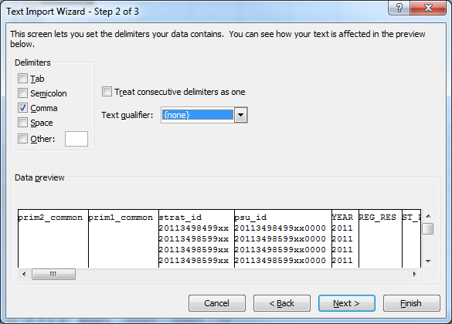

STEP 6
For step 3 of 3 in the Text Import Wizard, change the COLUMN DATA FORMAT to TEXT for each column that is losing precision. To do this, using the scroll bars in the DATA PREVIEW click on the column you wish to edit and then select the new data format. Note, the current data format is listed above the column name for every column. These must be changed individually.
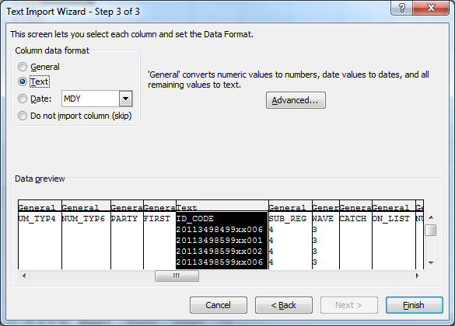
STEP 7
Click FINISH when done, OK on where to import to, and confirm your values have not been rounded

